11. React-HOL

App.js:

import React, { useState } from 'react';
import CurrencyConvertor from './CurrencyConvertor';

function App() {
const [count, setCount] = useState(0);

// Increments and calls another function
const handleIncrement = () => {
increment();
sayHello();
};

const increment = () => {
setCount(count + 1);
};

const decrement = () => {
setCount(count - 1);
};

const sayHello = () => {
console.log("Hello! This is a static message.");
};

const sayWelcome = (msg) => {
alert(msg);
};

const handleSyntheticEvent = (e) => {
alert("I was clicked");
console.log(e); // Synthetic Event object
};

return (
<div style={{ padding: '20px' }}>
<h1>🎯 React Event Examples App</h1>

<h2>Counter: {count}</h2>
<button onClick={handleIncrement}>Increment</button>{' '}
<button onClick={decrement}>Decrement</button>

<br /><br />
<button onClick={() => sayWelcome("Welcome to the Event Example!")}>Say Welcome</button>

<br /><br />
<button onClick={handleSyntheticEvent}>Click Me (Synthetic Event)</button>

<br /><br />
<CurrencyConvertor />
</div>
);
}

export default App;

CurrencyConvertor.js
import React, { useState } from 'react';

const CurrencyConvertor = () => {
const [rupees, setRupees] = useState('');
const [euros, setEuros] = useState('');

const handleSubmit = (e) => {
e.preventDefault();
const euroValue = (parseFloat(rupees) / 89.5).toFixed(2); // 1 Euro ≈ ₹89.5
setEuros(euroValue);
};

return (
<div style={{ marginTop: '30px' }}>
<h2>Currency Converter</h2>
<form onSubmit={handleSubmit}>
<label>
Enter amount in ₹ Rupees:
<input
type="number"
value={rupees}
onChange={(e) => setRupees(e.target.value)}
style={{ marginLeft: '10px' }}
required
/>
</label>
<br /><br />
<button type="submit">Convert to Euros</button>
</form>
{euros && (
<p style={{ marginTop: '10px' }}>
💶 Equivalent in Euros: €{euros}
</p>
)}
</div>
);
};

export default CurrencyConvertor;
OUTPUT:
welcome
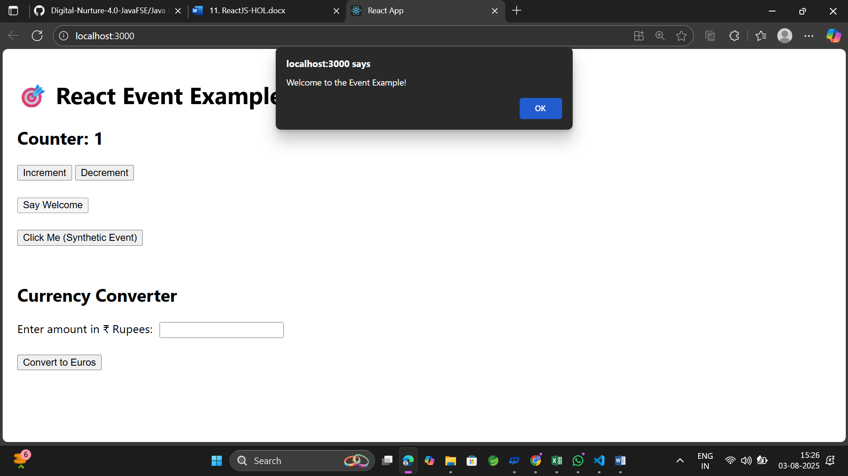

click

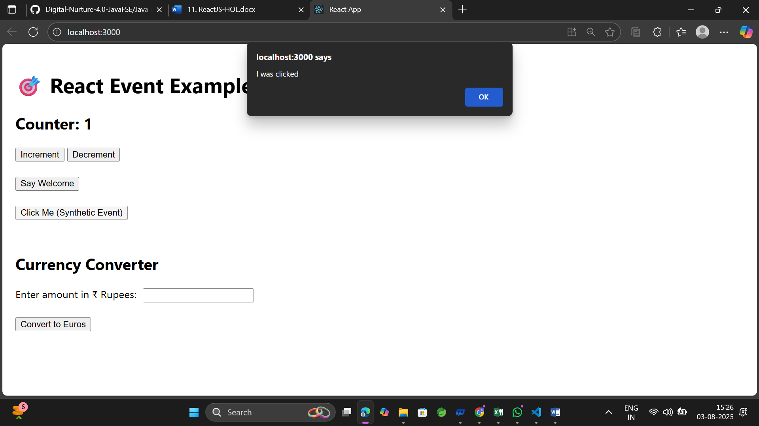

Currecncy converter

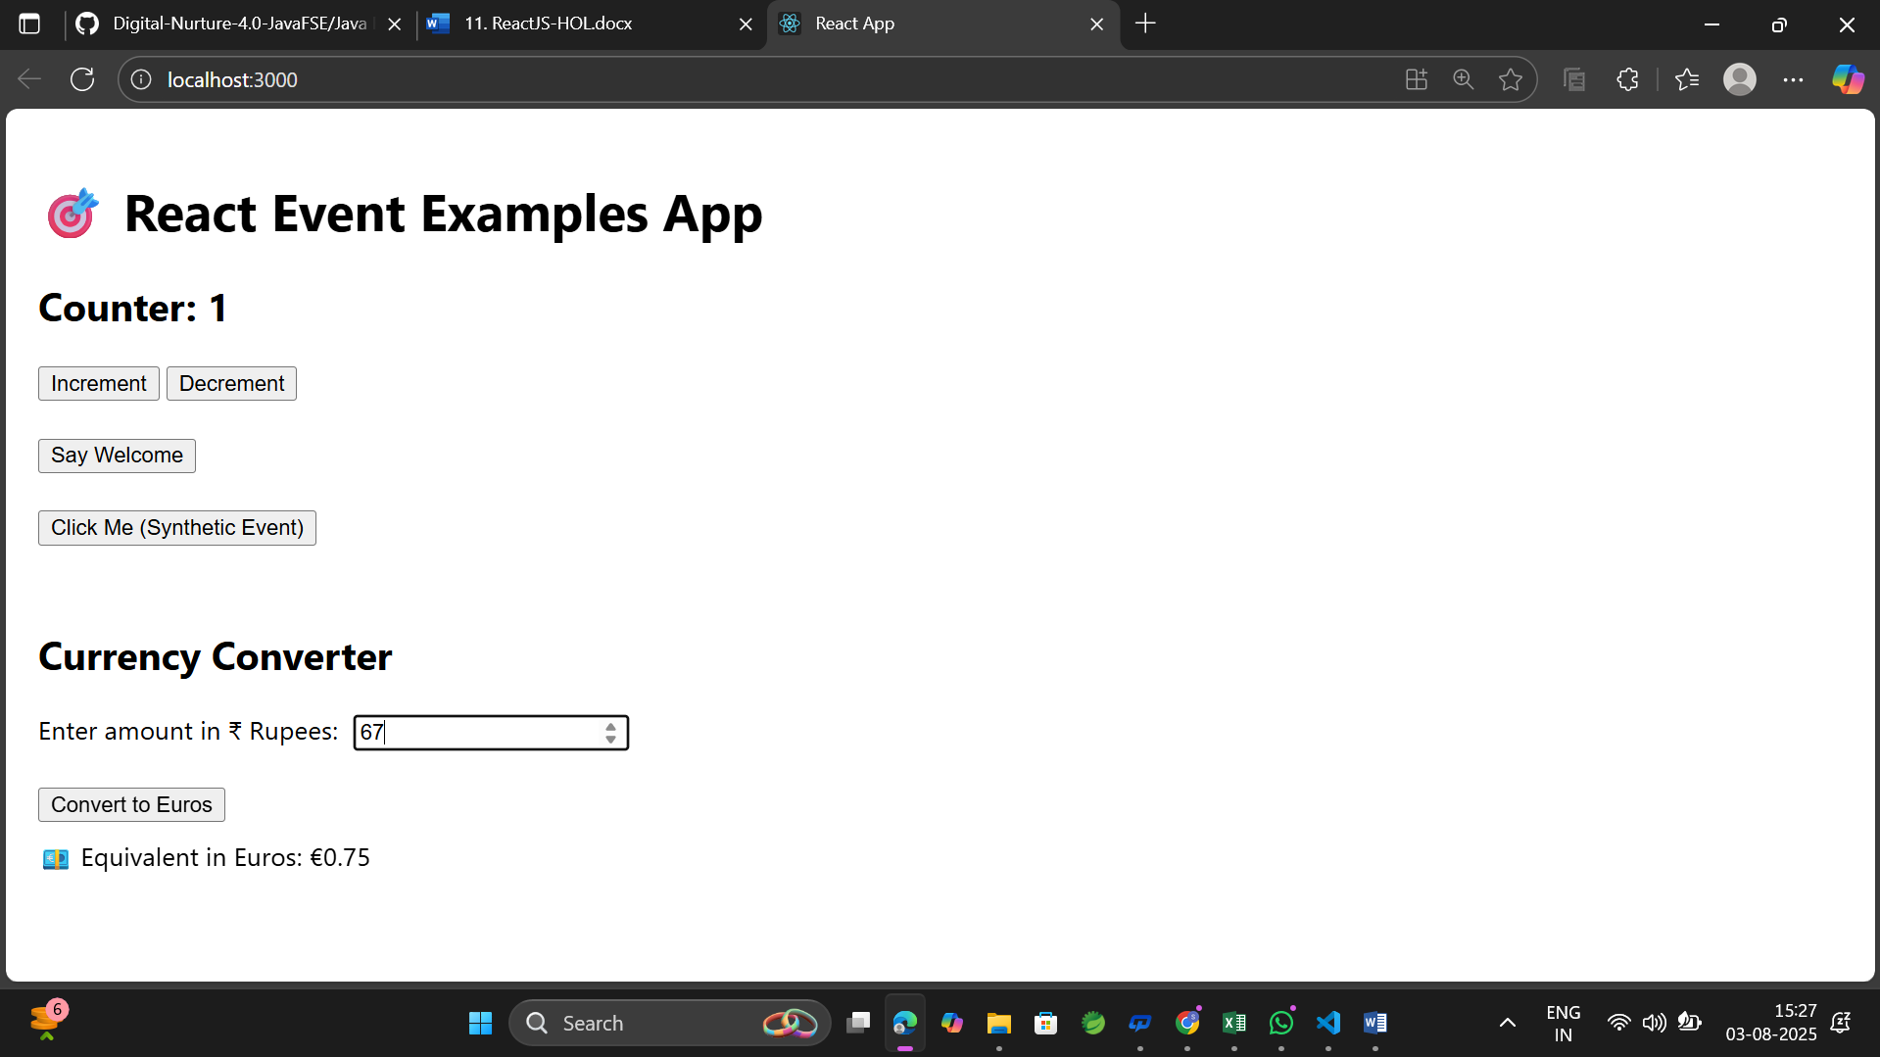

Increment:
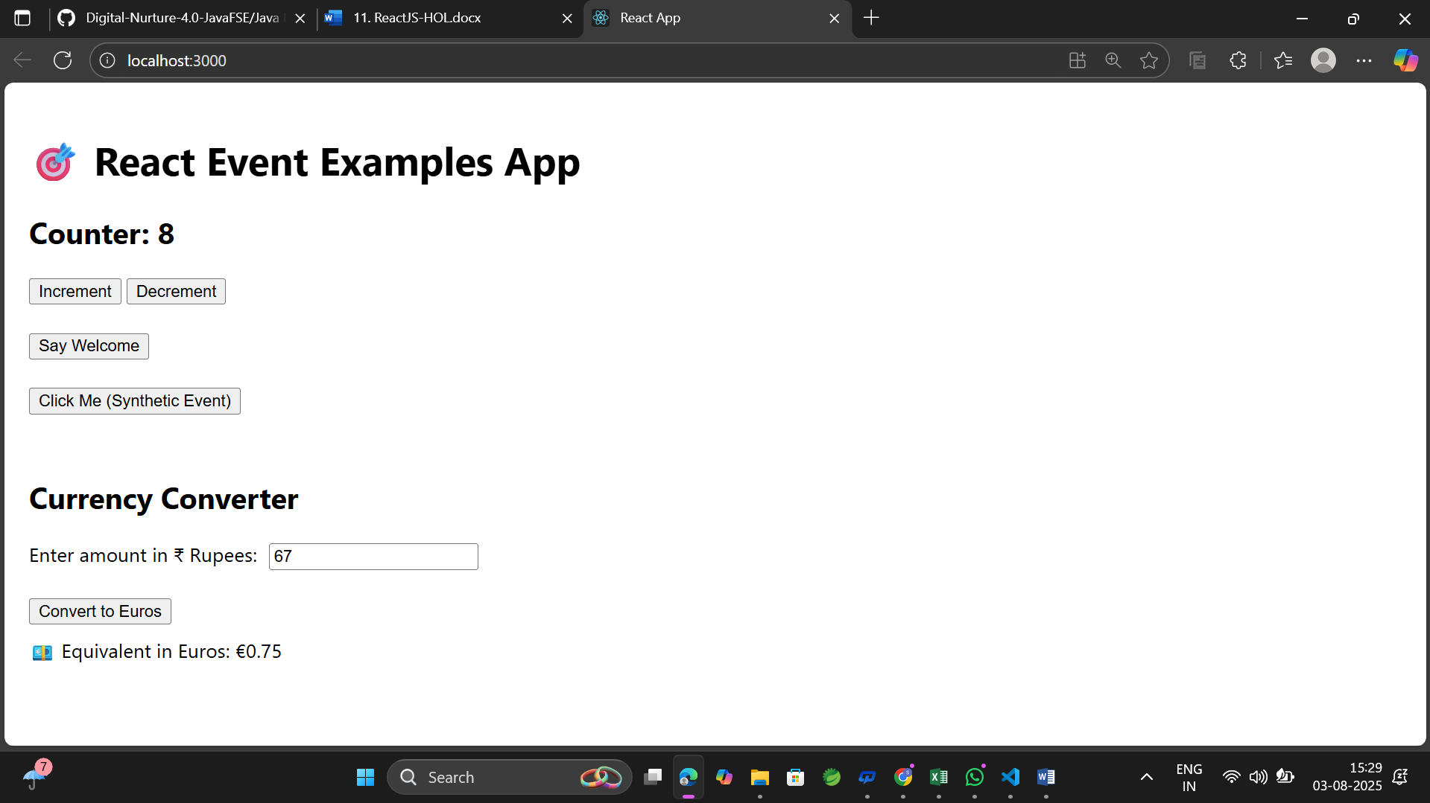

Decrement
